**Physical Education Lesson for the Week**

**June 1st -5th, 2020**

* **This Being the last week of school for the kids just take time to enjoy some family fun. The second set of our Virtual Field Day events and scorecard will be this week. Hopefully, everyone will enjoy the activities for the week. Do something this summer you have never done and maybe you will like it. It might even become your new favorite activity or hobby. Have a great summer and be safe everyone!**
* **Attached you will find a PE certificate for the kids to fill out. Since we will not be able to give out our awards this year, we ask you the parents to type or write your child’s name on it for the end of this school year. Stay active and see most of you next year!**
* **Monday-Friday** – Pick a day or choose multiple days during the week and do our Virtual PE Field Day with your family. At the bottom of the lesson you will see the activities for field day and a scorecard. The rules for each field day event are provided and on the scorecard, you will be able to mark all the points collected during the events you choose. Have fun with this and be safe!

**Be Safe, Be Healthy, Stay Active!**

**Shaler Area School District**

**Primary PE Department**

**Yours in Fitness and Health,**

**Mr. Chmielewski**

Virtual PE Field Day – Round Two

Each participant needs 1 scorecard. Choose a minimum of 5 events or try them all.

If you don’t have all the materials for at least 5 activities, then try as many as you can with the equipment available to you.

**Participant Name**: ____________________________________________

**School Name**: _______________________________________________

|  |  |  |
| --- | --- | --- |
| **3 OPEN National Field Day Rules:** | | |
| **BE SAFE** | **HAVE FUN** | **SPIRIT OF THE GAME** |
| **Spirit of the Game** *(noun)* An overarching concept that places the responsibility of fair play on each player. Respect, adherence to rules, and the joy of play are valued over competition. | | |

|  |  |  |  |
| --- | --- | --- | --- |
| **Event** | **Attempt #1** | **Attempt #2** | **Personal Best** |
| **Paper Plane Corn Hole** |  |  |  |
| **Penguin Race** |  |  |  |
| **Sock-er Skee-Ball** |  |  |  |
| **Spoon Relay** |  |  |  |
| **Tennis Shoe Tower** |  |  |  |
| **Towel Flip Challenge** |  |  |  |
| **Wash Your Hands Relay** |  |  |  |
| **Water Bottle Trap** |  |  |  |
| **Wind Bowling** |  |  |  |

Have Fun with this and send your PE Teacher some pictures, so we can see how you are doing at home. Good Luck!

PAPER PLANE CORN HOLE

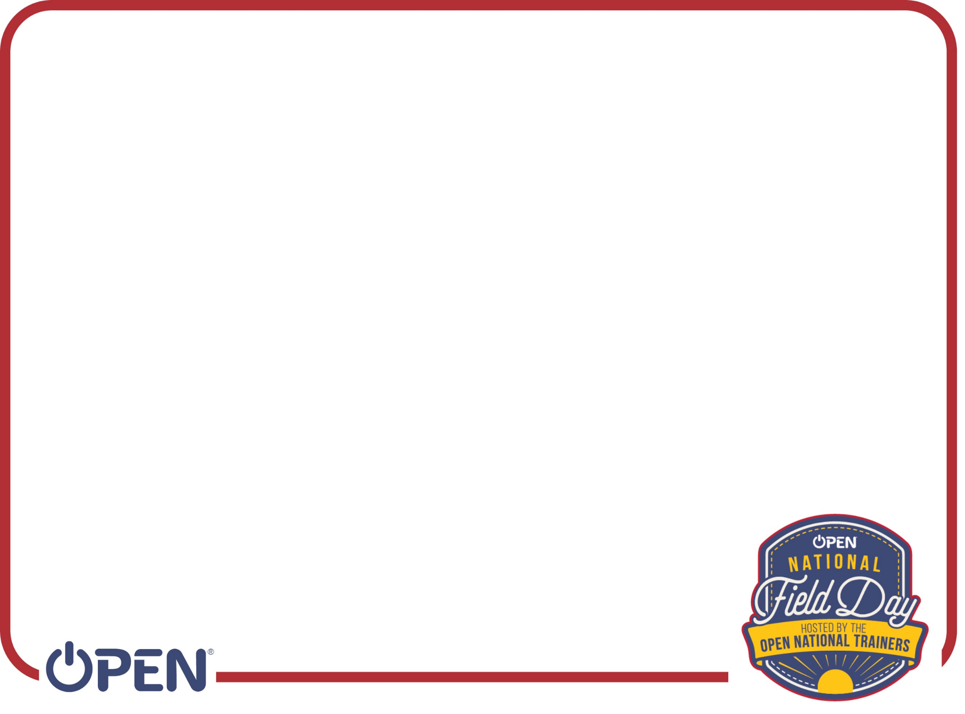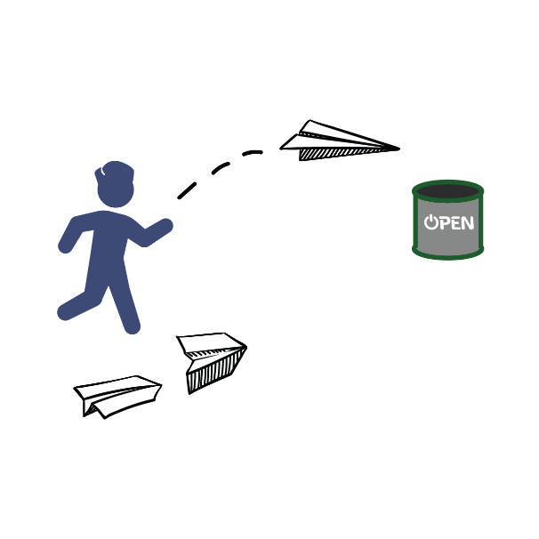

**Get** **Ready:** You’ll need 3 paper sheets per player, a bucket or laundry basket.

**Get** **Set:** Create 3 paper airplanes using a design of your choice. Place your bucket 5-10 feet away from your throwing line.

**GO!**

· This event is called Paper Plane Corn Hole. · The object of the game is to score points by

throwing your paper airplane into your bucket. You have 1 minute to score as many as possible.

· Design and create 3 paper airplanes.

· On the start signal, fly your airplanes as many times as you can toward your bucket.

· Score 1 point for every plane that hits the outside of the bucket and 2 points for every plane that lands in the bucket.

· Write your score down on the official Field Day Score Card.

PENGUIN RACE

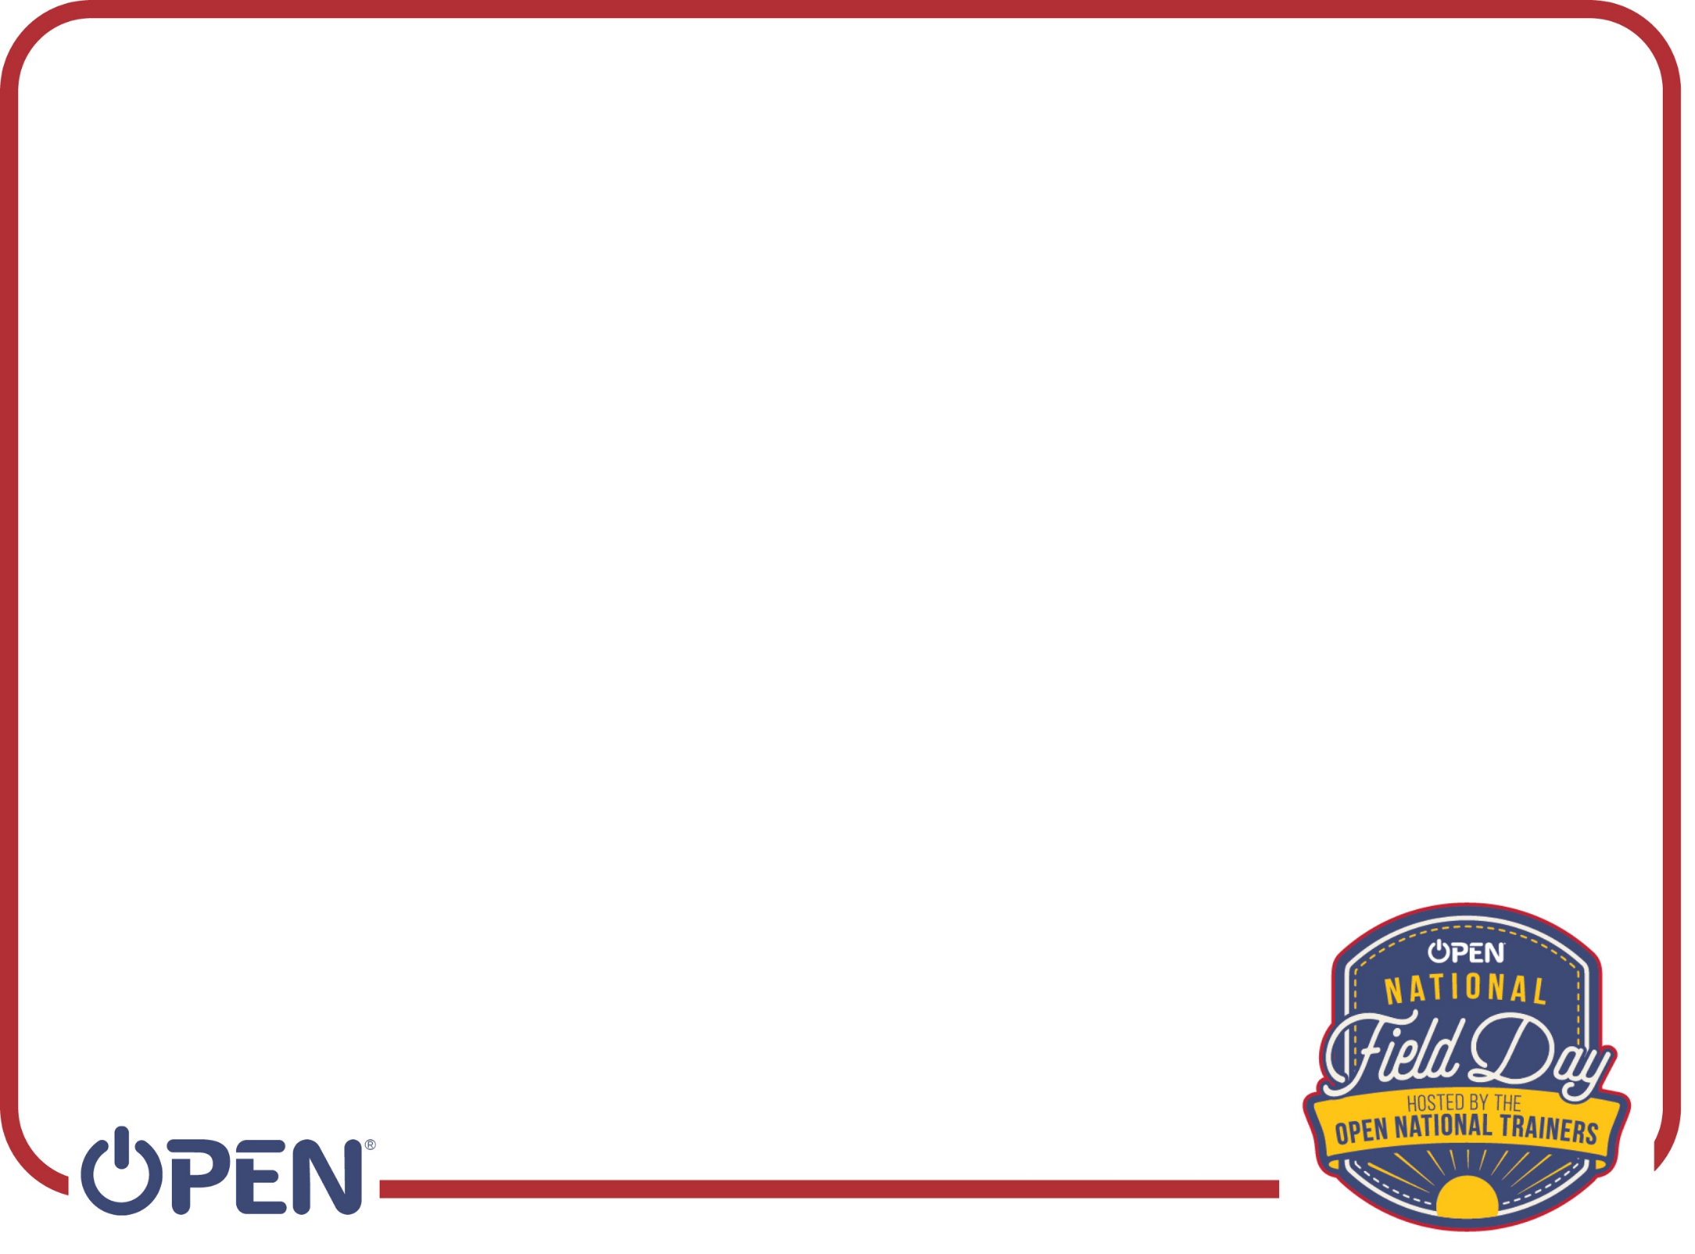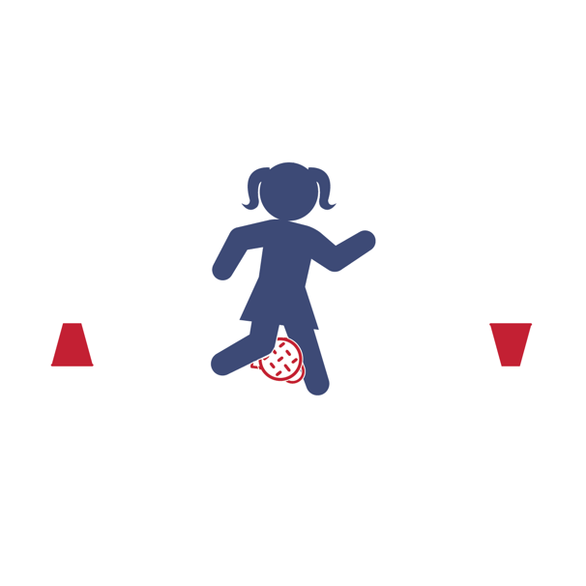

**Get** **Ready:** 1 Sock or Tennis Ball and 2 Plastic Cups per Person **Get** **Set:** Set the plastic ups 15-20 ft. from each other.

**GO!**

· You are a Penguin – the ball is an egg. · There are 2 different ways to play:

(1) By Yourself or (2) Race A Partner.

· ***By*** ***Yourself*** ***Challenge*** – How many points you can score in 1-minute?

oPlace the egg between your knees and waddle back and forth from one cup to the other. When you reach the cup, turn it over.

oIf you drop the egg, do 5 jumping jacks before you continue.

oScore 1 point for each cup you turn over.

· ***Race*** ***A*** ***Partner*** ***Challenge*** – Be the first Penguin to turn over 6 cups! oOn the start signal, waddle to the first cup and turn it over.

oNow hustle back to the other cup (as much as one can hustle while waddling). Continue back and forth.

oIf you drop the egg, do 5 jumping before you continue. oFirst to turn over 6 cups wins the race (scores 6 points).

SOCK-ER SKEE-BALL

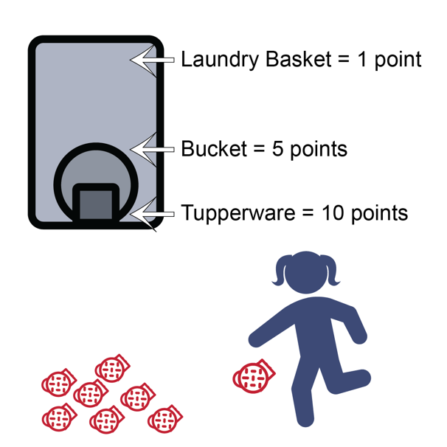

**Get** **Ready:** 10 sock balls, 1 Laundry Basket, 1 Bucket, 1 Tupperware container

**Get** **Set:** Roll up the socks to make sock-balls. Stack the targets into skee-ball formation with the Tupperware inside the bucket and the bucket inside the laundry basket.

**GO!**

· This event is called Sock-er Skee-ball. The object of this game is to score points by kicking the sock ball into the skee-ball targets.

· You’ll do that by using your feet to kick the sock ball into the target.

· Score 1 point for every sock ball that lands in the laundry basket.

· Score 5 points for sock balls in the bucket.

· Score 10 points for sock balls in the Tupperware container. · You get 10 chances to score as many points as you can.

· Write your score down on the official Field Day Score Card.

SPOON RELAY

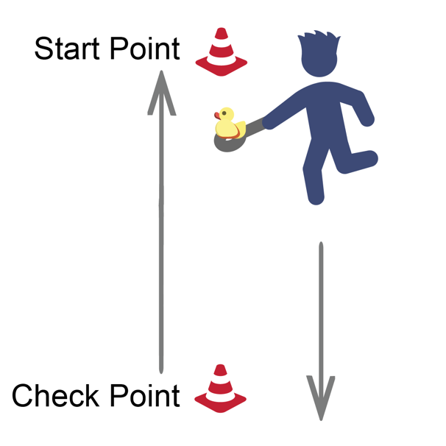

**Get** **Ready:** 1 spoon, 1 object to balance (small ball, marble, small toy), Items to Mark Start/Check Points (cones, socks, plastic cups, etc.), Clock or Stopwatch

**Get** **Set:** Set a starting point and a check point. Distance can be 15 to 30 walking steps from beginning to end. At the start point, get ready by placing the object on the spoon and balance it.

**GO!**

· This is the Spoon Relay. You have 1 minute to Score points by completing laps with an object balanced on a spoon.

· On the start signal, move carefully from the starting point to the check point and back again (1 lap).

· Complete as many laps as possible without a drop.

· If you drop the object, stop walking, place it on the spoon, and begin again.

· Score 1 point for each lap completed without a drop.

· Write your score down on the official Field Day Score Card.

TENNIS SHOE TOWER

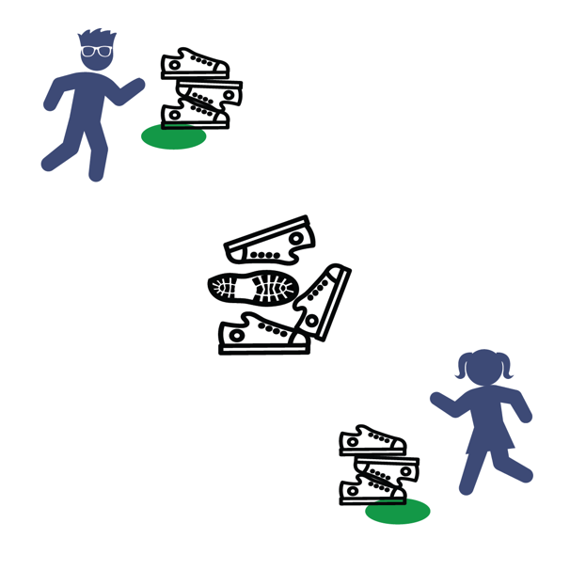

**Get** **Ready:** 5-10 Shoes per Player, 1 Spot Marker per Player to Create Home Base for Each Player (paper plate, cups, sock etc.)

**Get** **Set:** Place shoes in a pile in the center of the room. Place Home Base spots 6’-10’ from the pile and 6’ apart from other players.

**GO!**

● This event is called Tennis Shoe Tower.

● The object is to build a shoe tower with shoes collected from the pile.

● On the start signal, players will run and take 1 shoe from the pile, return it to their home base and place it on their shoe tower.

● Repeat till all the shoes are gone. (Run – Grab – Stack – Repeat!) ● If the tower falls, that's okay. Continue stacking to rebuild

and continue.

● On the stop signal, count and score 1 point for each shoe in the tower.

● Write your score down on the official Field Day Score Card.

TOWEL FLIP CHALLENGE

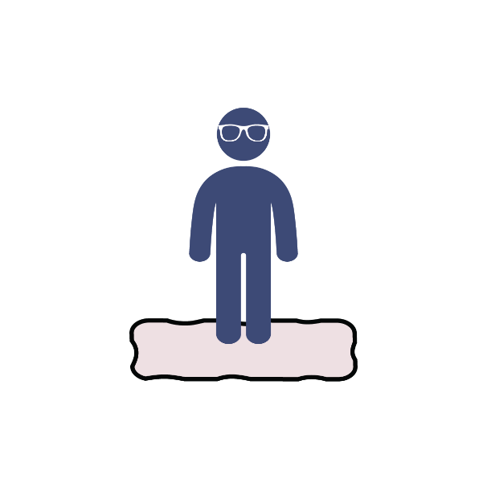

**Get** **Ready:** 1 large beach or bath towel

**Get** **Set:** Lay your towel out flat on your floor and stand on it.

**GO!**

· This event is the Towel Flip Challenge. The object of this game is to flip the towel as fast as you can without stepping off of it.

· You can take small steps from one part of the towel to another. However, you can only move it when you have both feet firmly in place on top of the towel.

· The towel must be flat at the start and flat at the finish.

· You have 1 minute to complete the challenge.

WASH YOUR HANDS RELAY

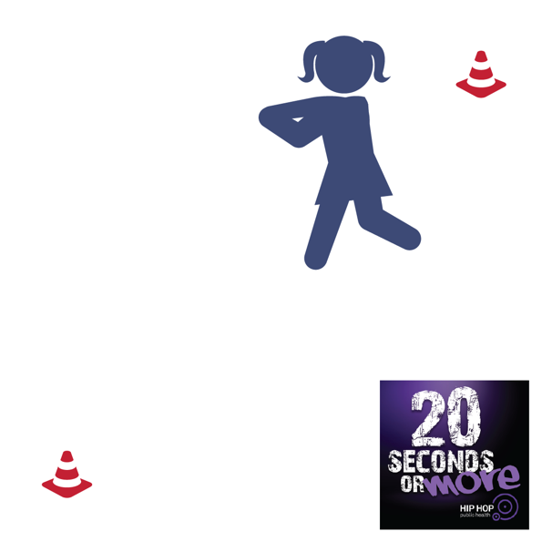

**Get** **Ready:** [20 Seconds or More Music by Doug E. Fresh](https://hhph.org/20secondsormore/), 2 Objects (shoes, cones, plastic cups)

**Get** **Set:** Create 2 end lines by setting objects 6’ to 12’ apart in an area safe for movement. Play 20 Seconds or More by Doug E. Fresh

**GO!**

● This event is called Wash Your Hands Relay!

● The song 20 Seconds or More helps to teach us how to wash our hands and keep our family safe from disease.

● The object of this game is to move from line-to-

line as many times as you can in 1 minute while pretending to wash your hands.

● You must walk, skip, or gallop. Running or jogging is not allowed. ● On the start signal, begin moving from line-to-line.

● Count each time that you move to an end line.

● On the stop signal, record your score on the official Field Day Score Card.

Water Bottle Trap

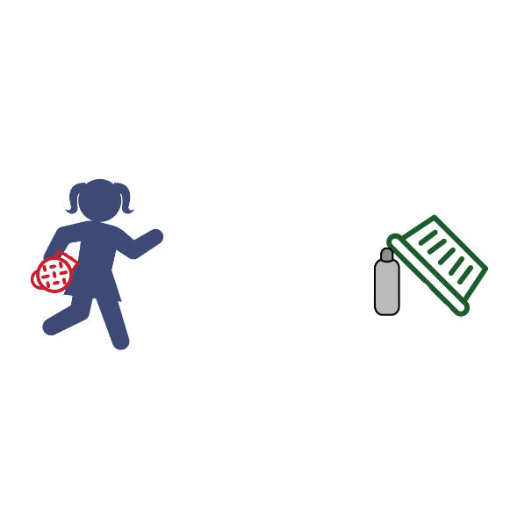

**Get** **Ready:** 1 Empty Water Bottle, 1 Laundry Basket, 1 Sock/Tennis Ball

**Get** **Set:** Lean the edge of the laundry basket on top of the empty water bottle. Designate a rolling line 8-10 ft. away (the open side

of the laundry basket should be facing you).

**GO!**

· The objective is to see how many points you can score in 1-minute.

· Do this by rolling the sock/tennis ball at the water bottle.

· To score the ball must hit the water bottle first (the roll does not count if it misses the bottle and knocks over the basket – sorry!).

· Rolls that hit the water bottle first score as follows: 1 point = basket falls and traps ball only

2 points = basket falls and traps water bottle only

3 points = basket falls and traps both ball and water bottle · Write your total number of points on the official Field Day

Score Card.



WIND BOWLING

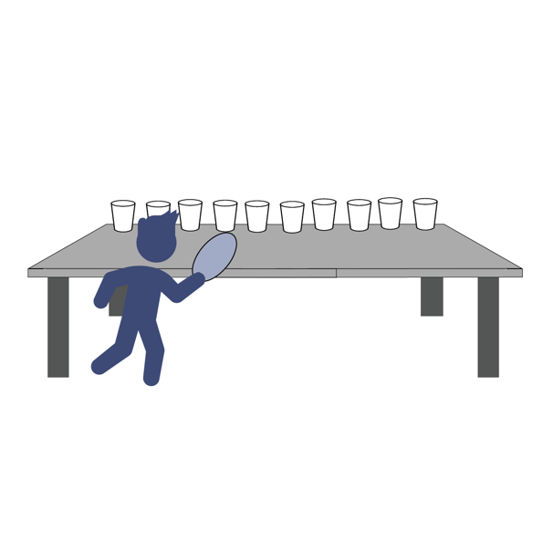

**Get** **Ready:** 1 Balloon (or Paper Plate), 10 Plastic Cups

**Get** **Set:** Set 10 empty plastic cups at the edge of a table in single file along the edge.

**GO!**

· This event is called Wind Bowling. The object of the game is to knock all the cups off a table edge using only the air from the balloon or paper-plate fan.

· You’ll do that by blowing the balloon up and aiming the escaping air towards the empty plastic cups. If you don’t have a balloon you can wave the paper plate like a fan with the fan’s air hitting the cups.

· Score a point for every cup that gets knocked off the table.

· You have 1 minute to knock down as many cups as you can. · Write your score down on the official Field Day Score Card.



**PE Teacher**- **Mr. C.**



**PE Teacher**- **Mr. Brough**

Shaler Area Physical Education 2020

#### ___________________

Shaler Area Virtual PE Award

In recognition of outstanding performance in physical activity